Christian Clark

CIS 123

CH8 Screenshots

1. Disadvantages of Register Parameters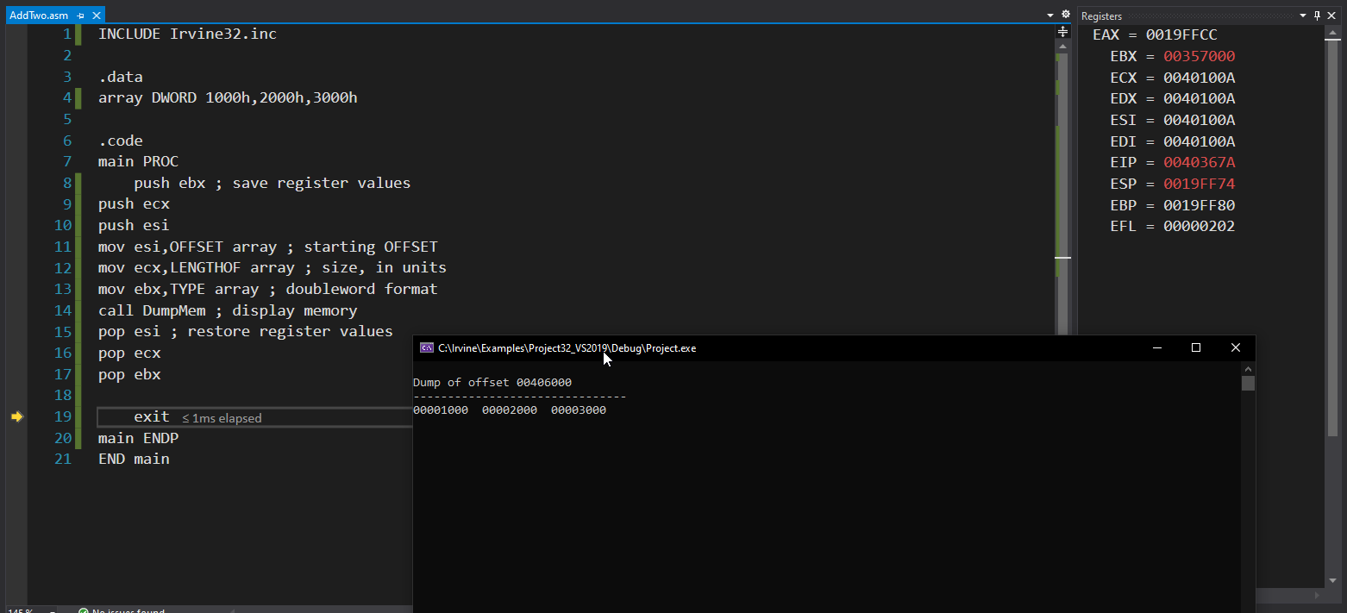

2. Accessing Stack Parameters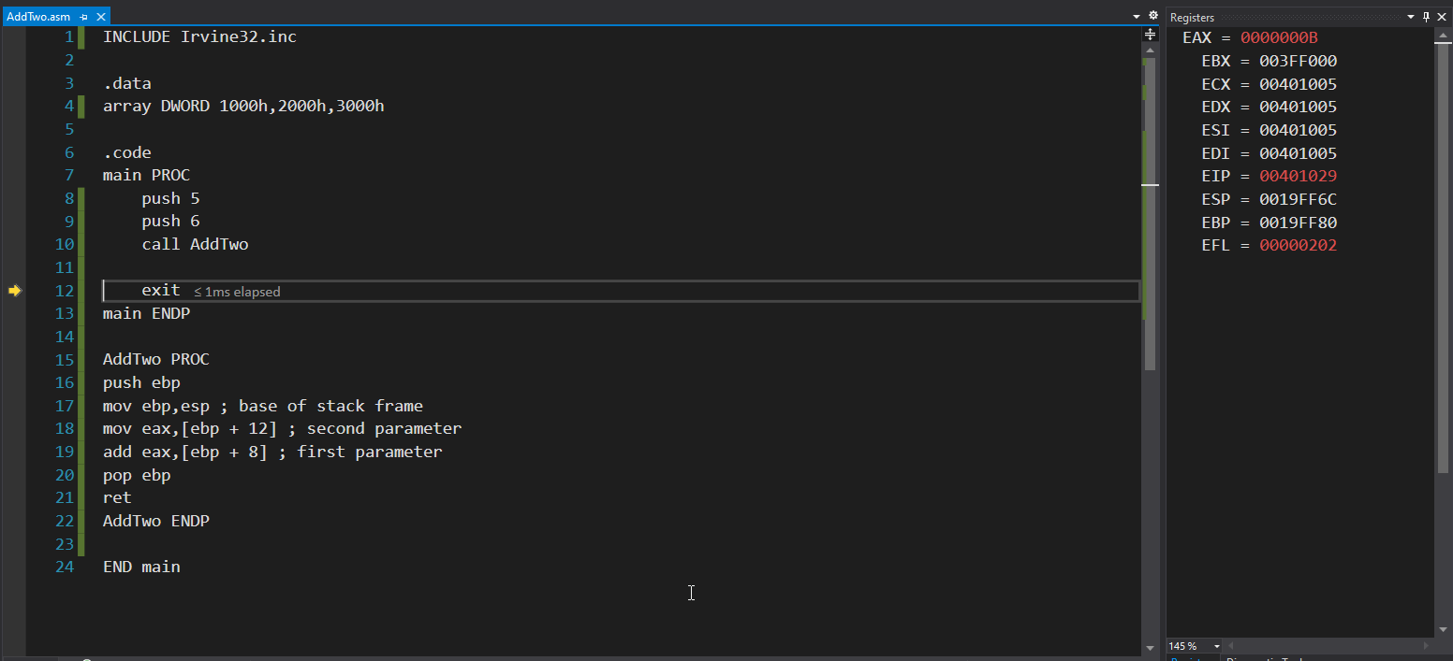

3. Corrupted stack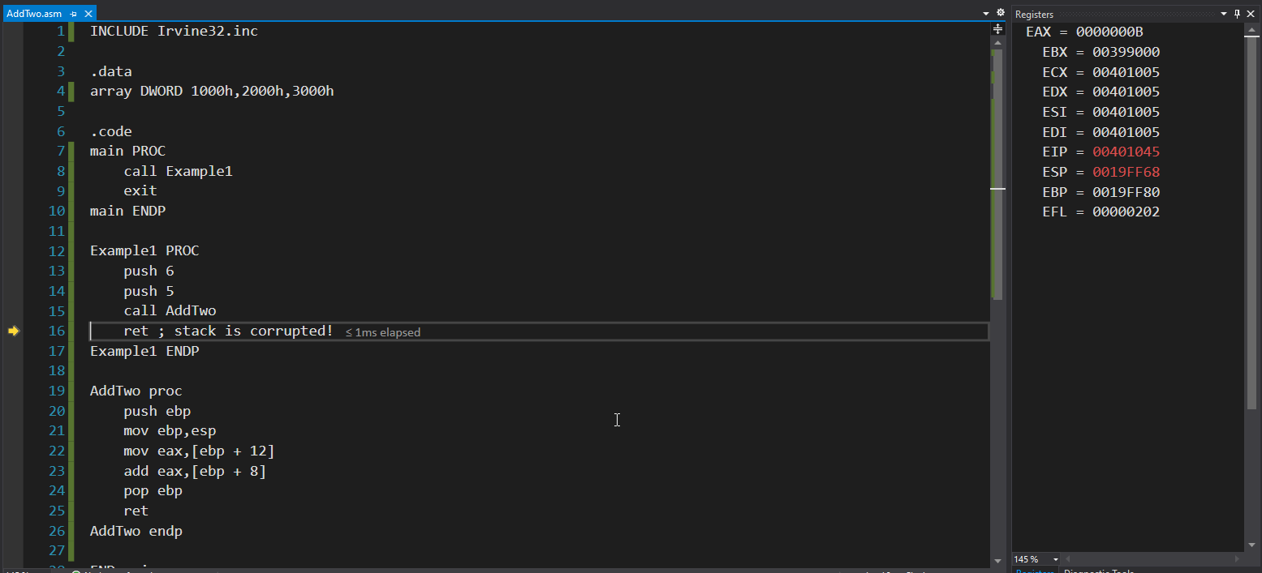

4. STDCALL convention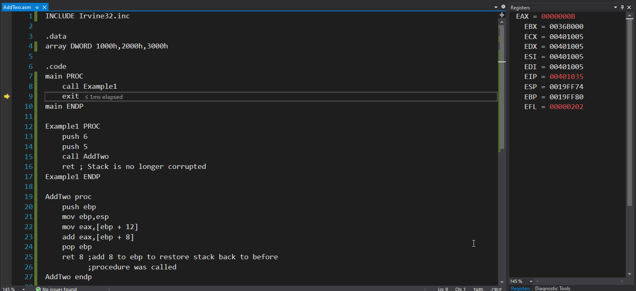

5. Saving and restoring registers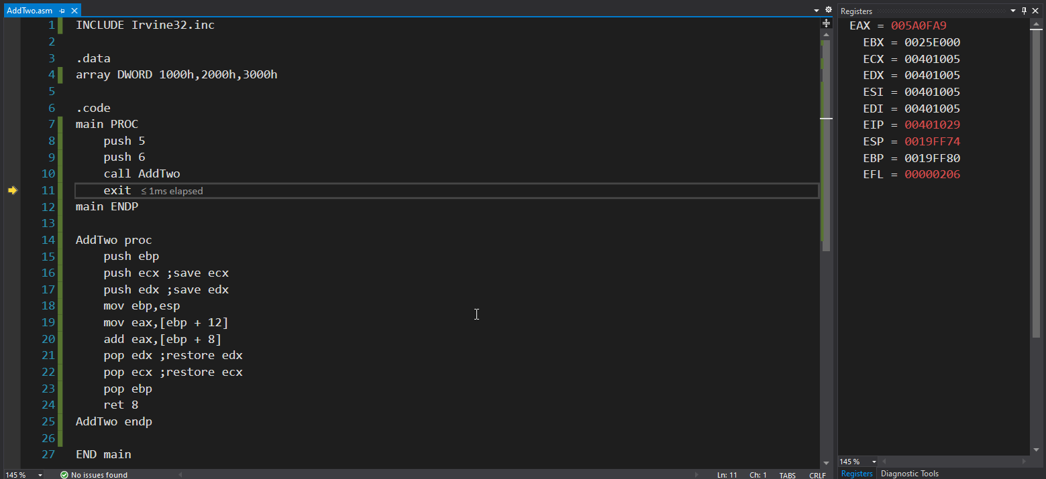

6. Local Variables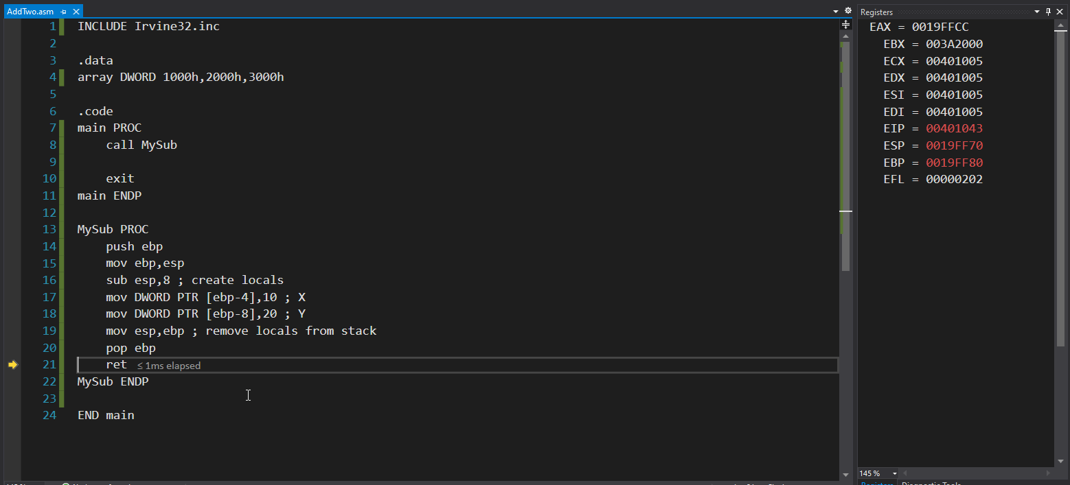

7. Reference Parameters/ArrayFill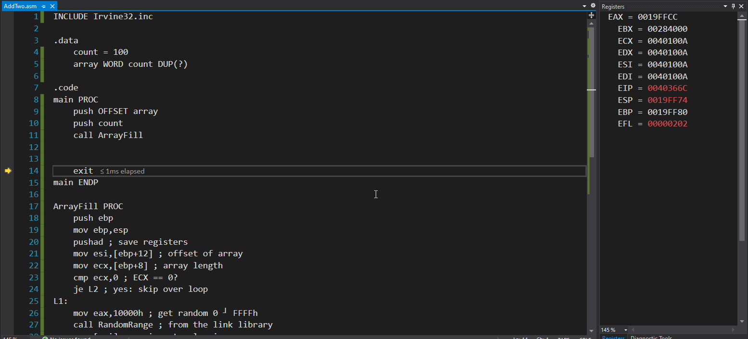

8. LEA instruction 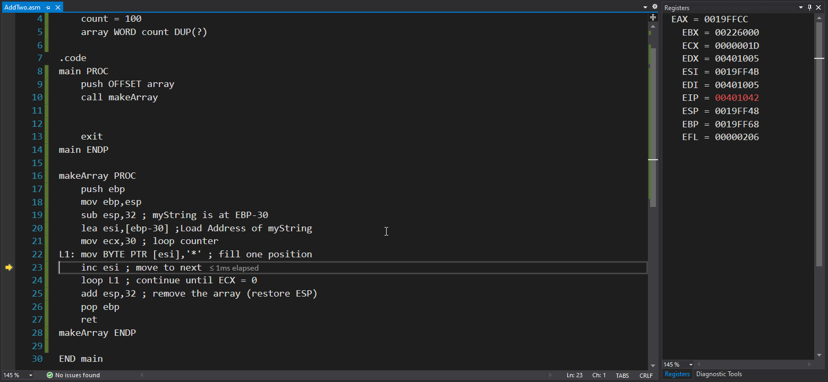

9. LOCAL directive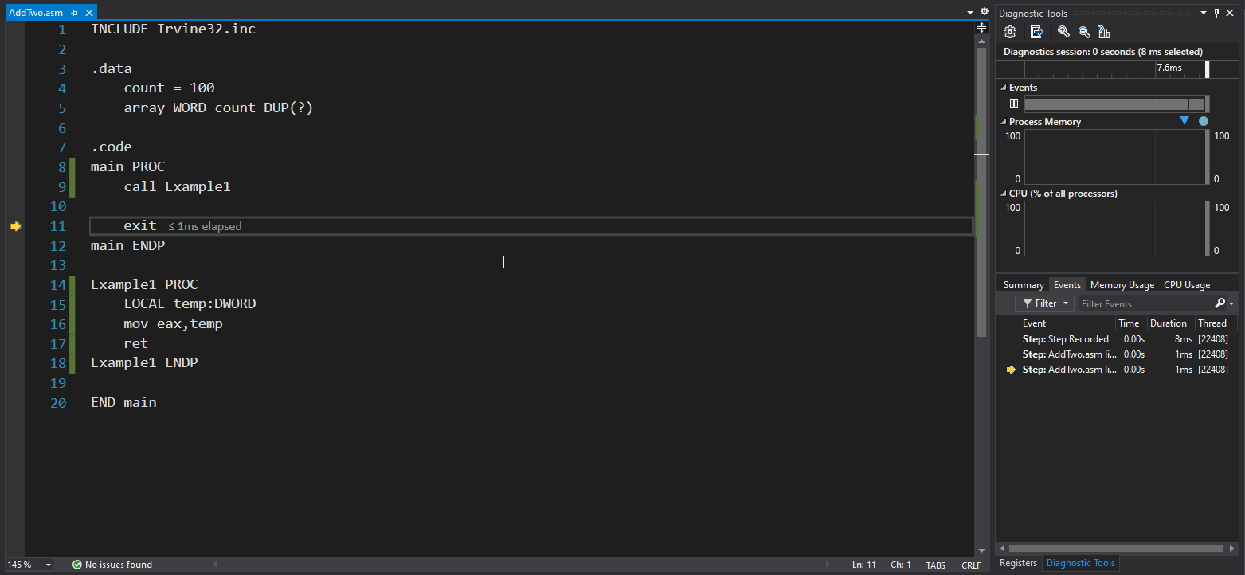

10. RecursiveSum.asm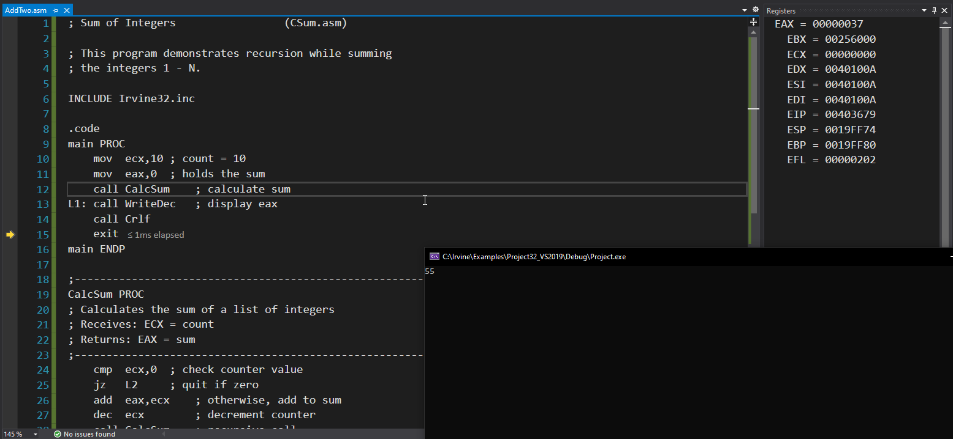

11. Fact.asm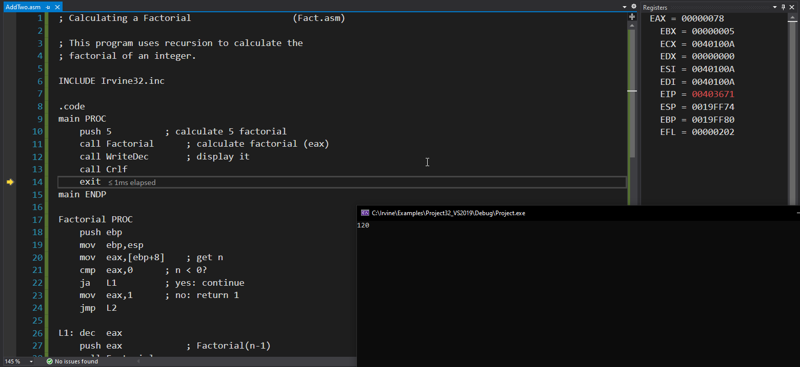

12. INVOKE, PROTO, ADDR, and PROC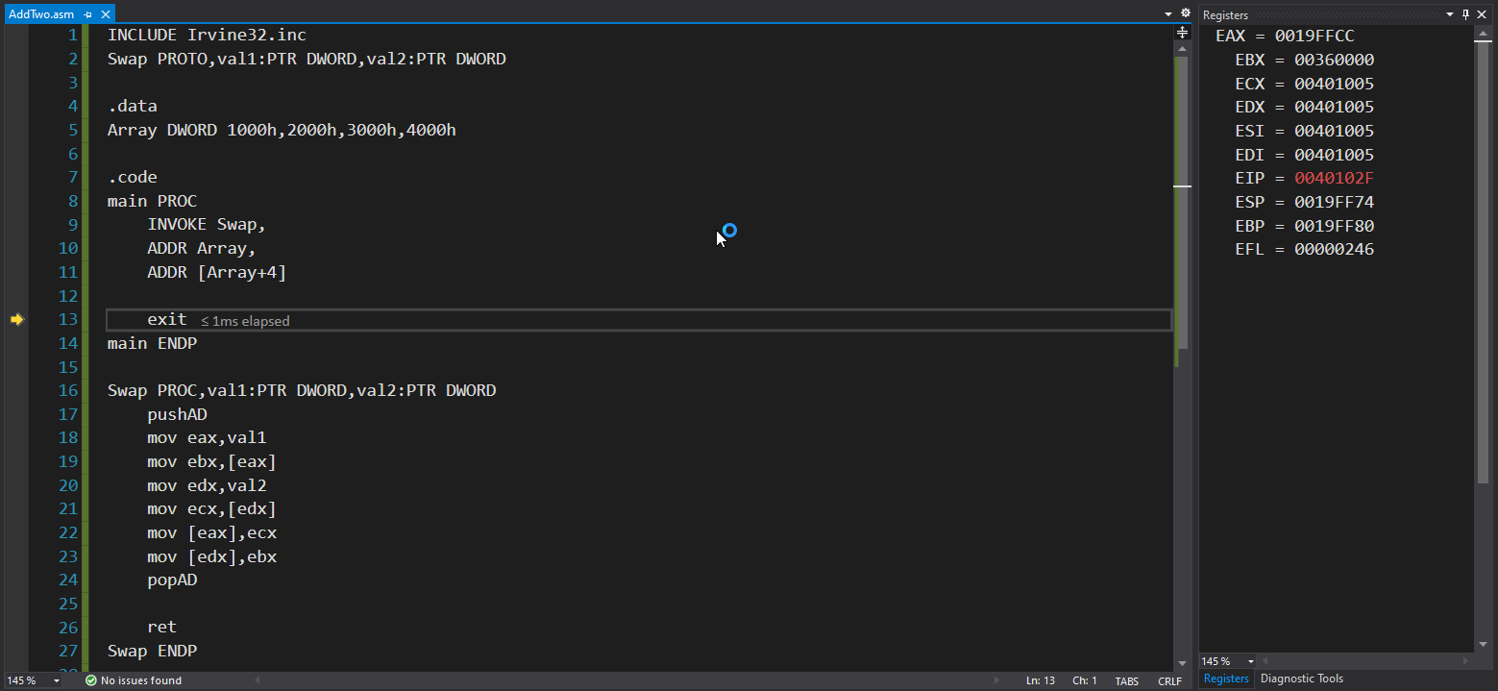

13. Swap.asm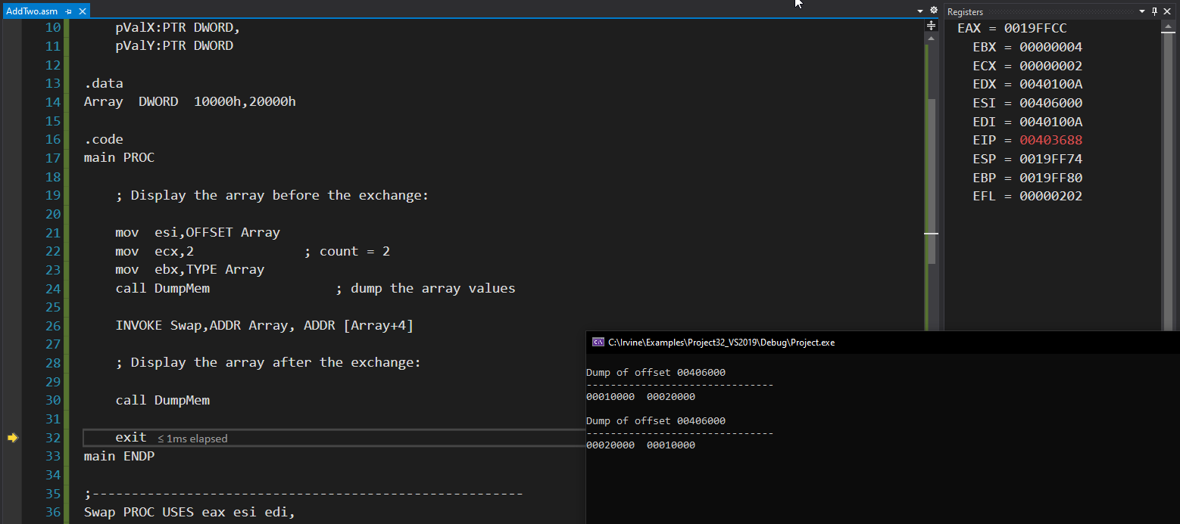

14. Calling External Procs & using variables and symbols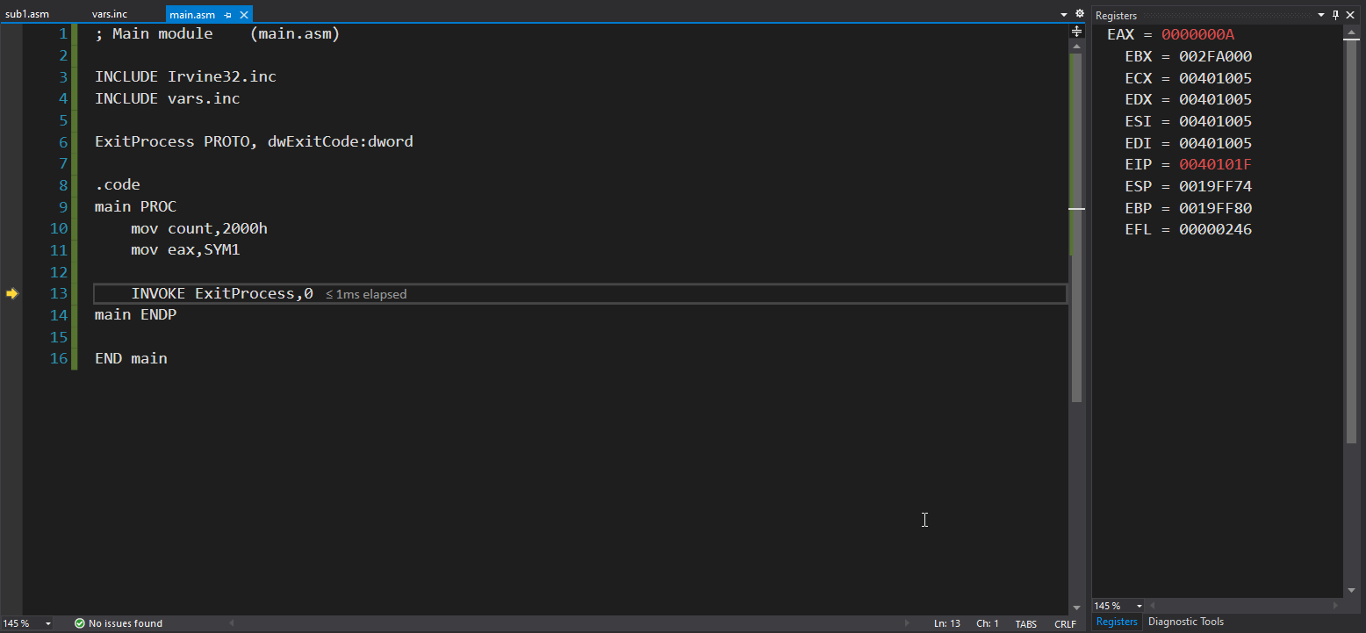

15. Prompt.asm/sum.inc/arrysum.asm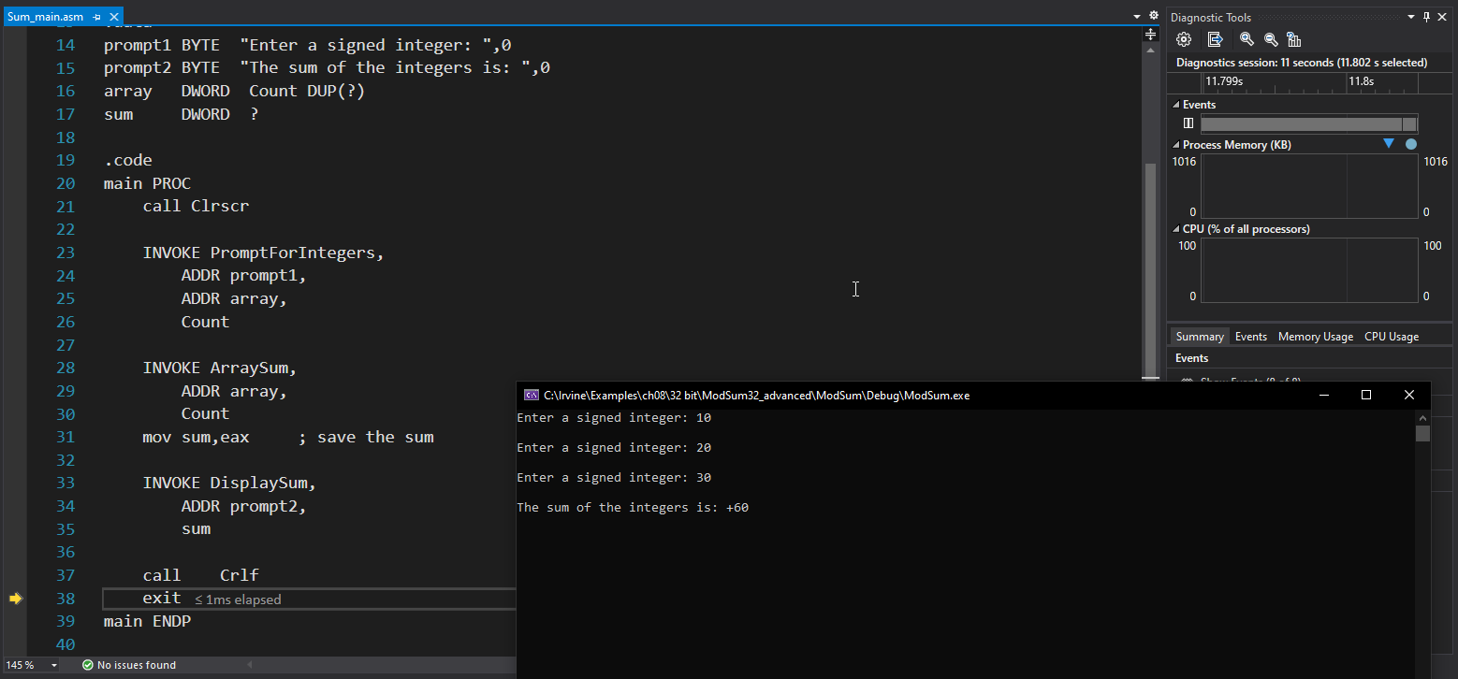

16. USES operator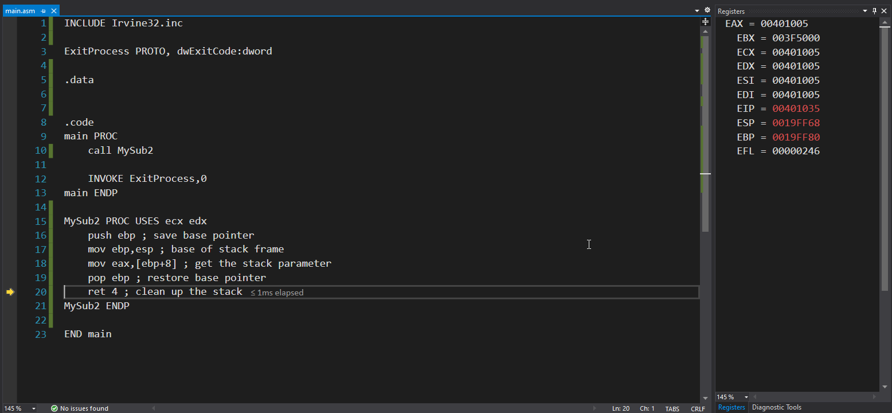

17. WriteHex64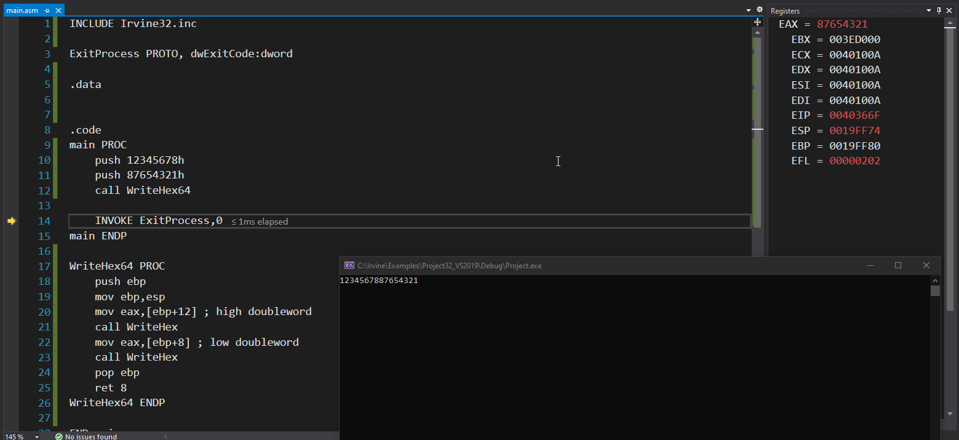

18. There is not any code to run on these pages but I have read the java bytecode section